# PRACTICAL - 1

**1.1)**

**AIM:** Installation & Configuration of Android Studio. Along with its all major Gradle, SDK, AVD etc.

**PROCEDURE:**

1. Go to the android developer website and search for the latest version of android studio for your windows. Check all the basic requirements of your laptops/pcs needed and then download it by clicking on the link shown below.

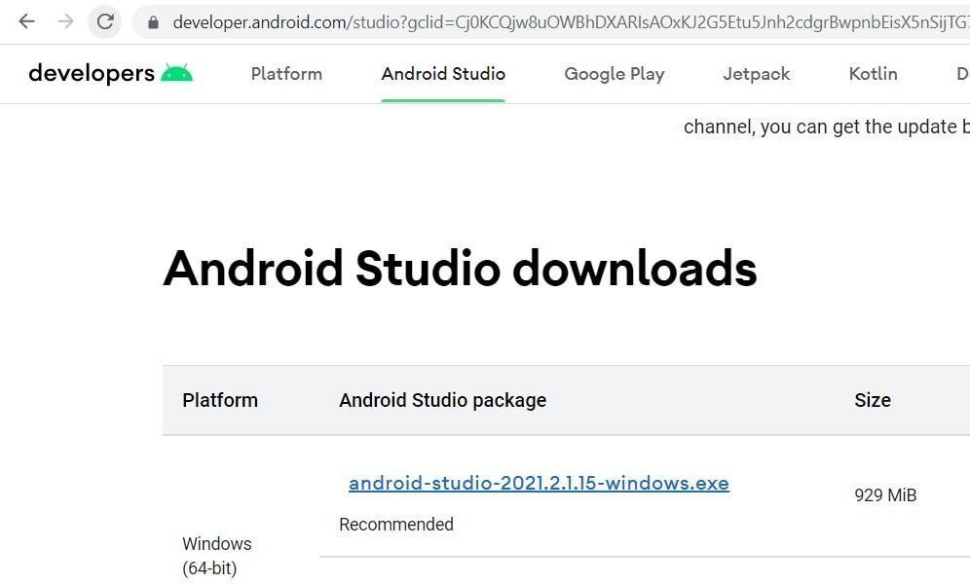

1. After reading all the terms and conditions, click on I accept the terms and conditions & then click on the green button to actually download it. Make sure that you have a good wifi connection available.

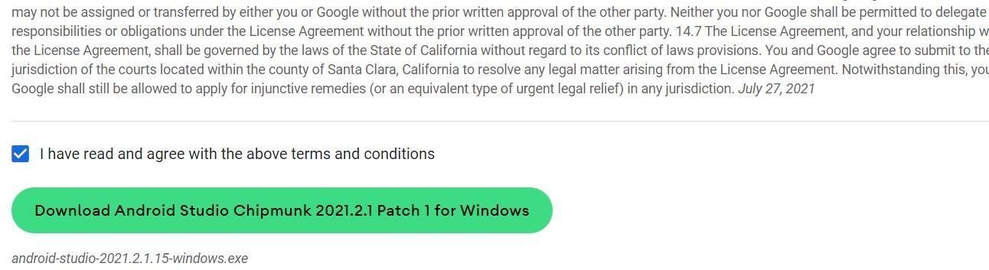

1. Click on next.

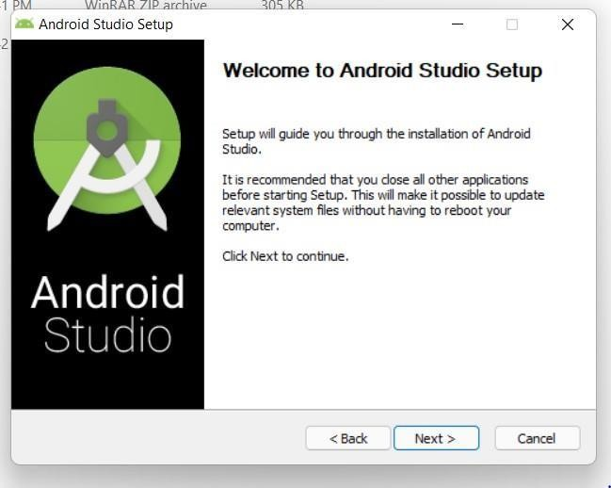

1. Check on the Android Virtual Device and then click next.

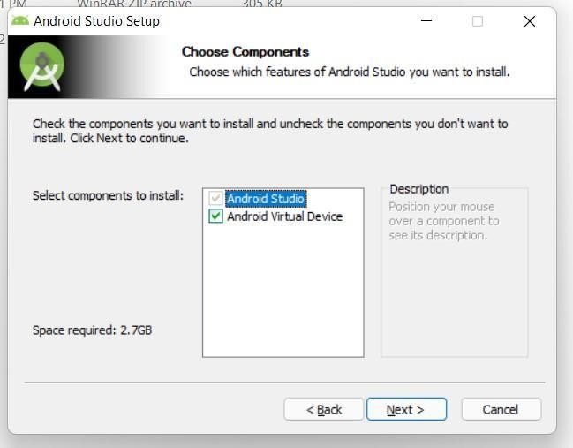

1. If you want to change the location of installation, browse the folder first & click on next.

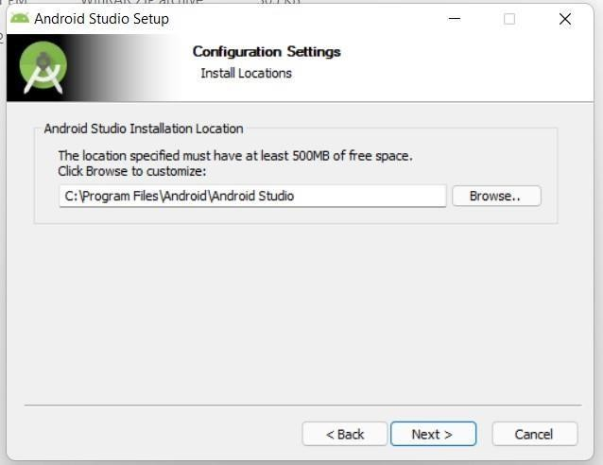

1. Click on install.

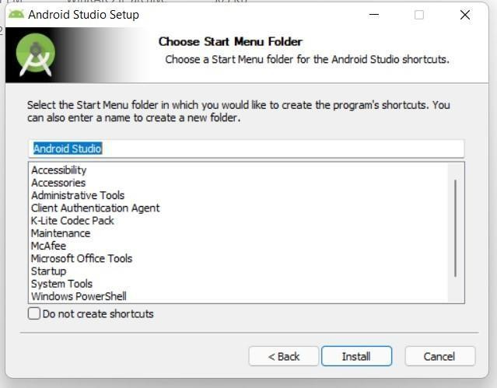

1. Let all the extract complete. After completion, click on next.

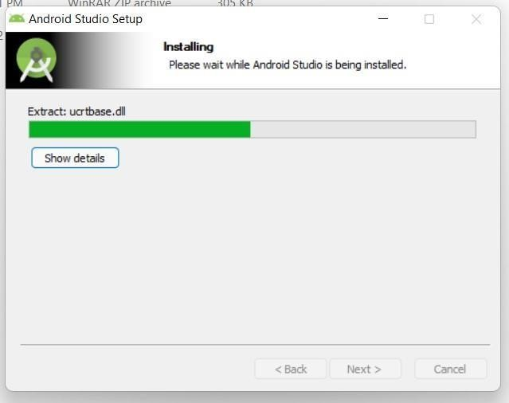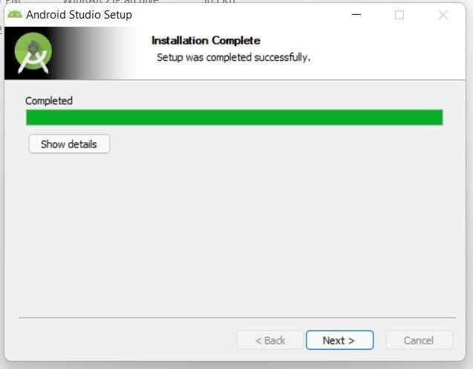

1. Click on finish.

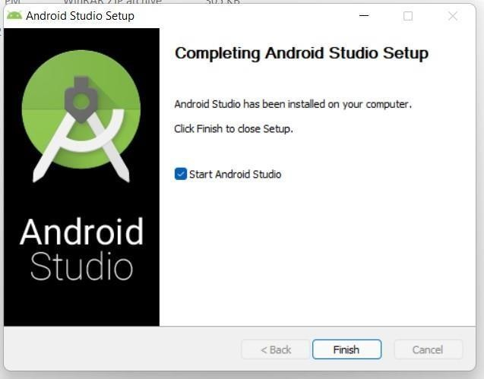

1. After clicking on either don’t send or send usage, click on next.

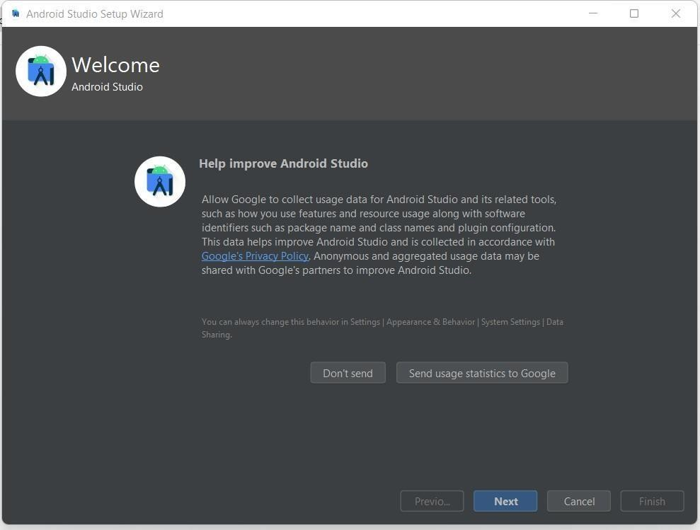

1. Click on next

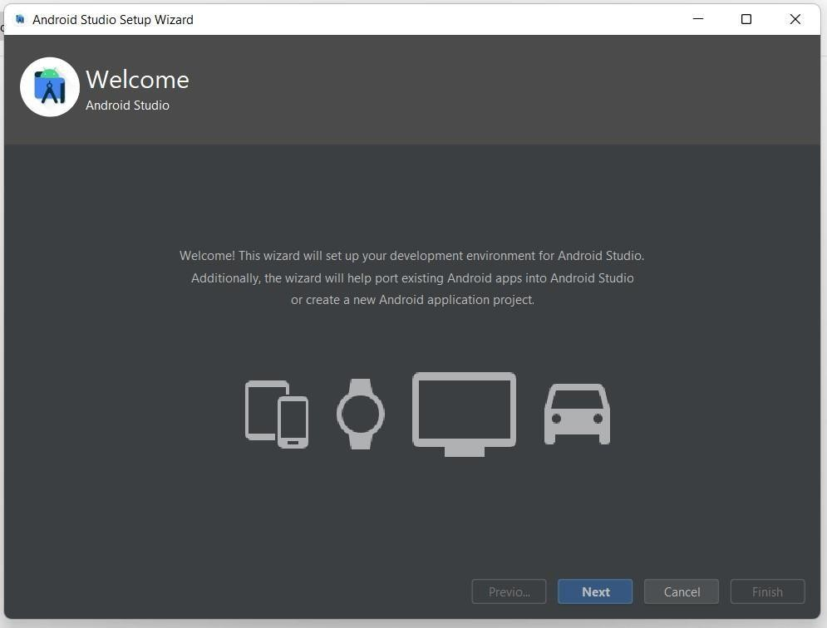

1. Select standard setup and then click on Next.

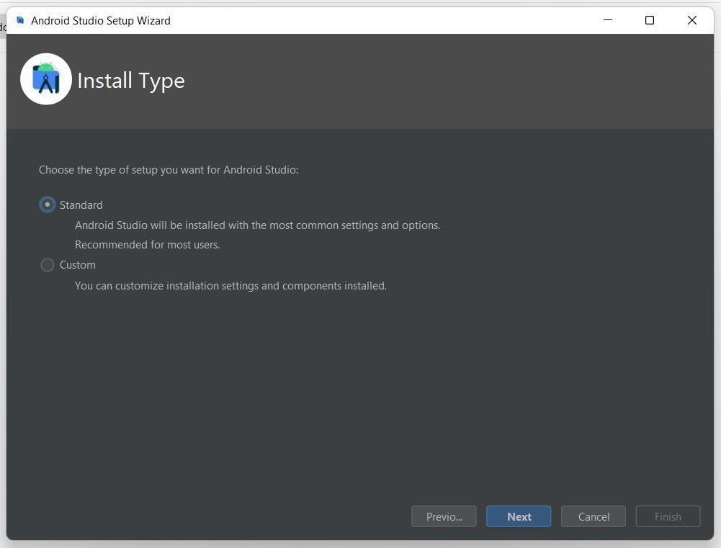

1. Select any one UI Theme according to your preference. Then click on next.

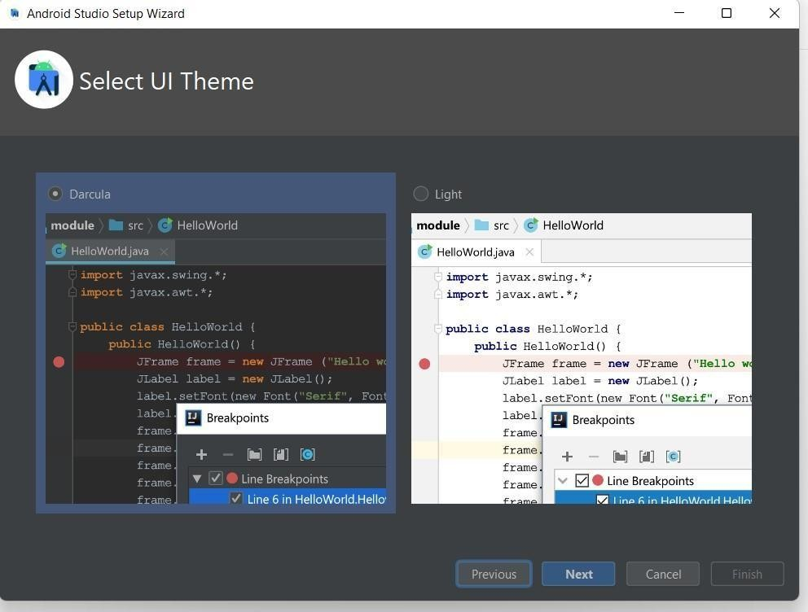

1. Click on next.

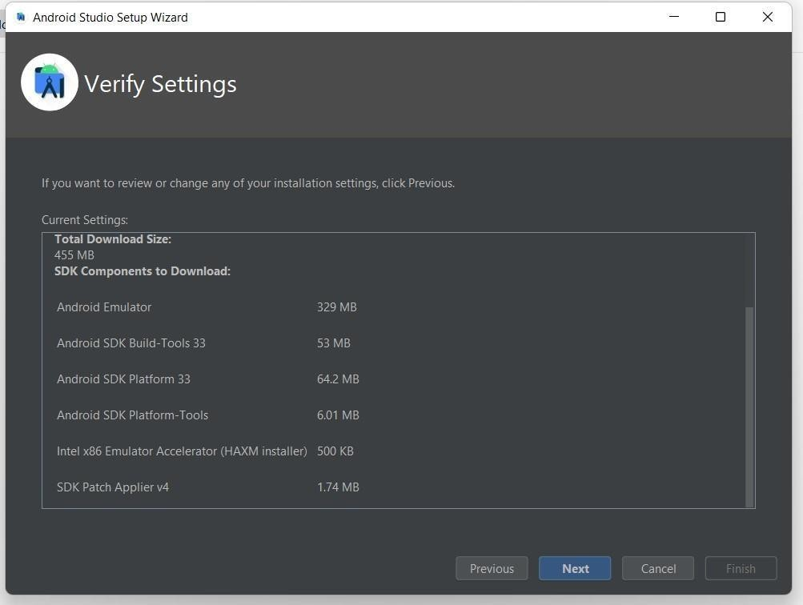

1. Click on accept for both the license and then click on finish.

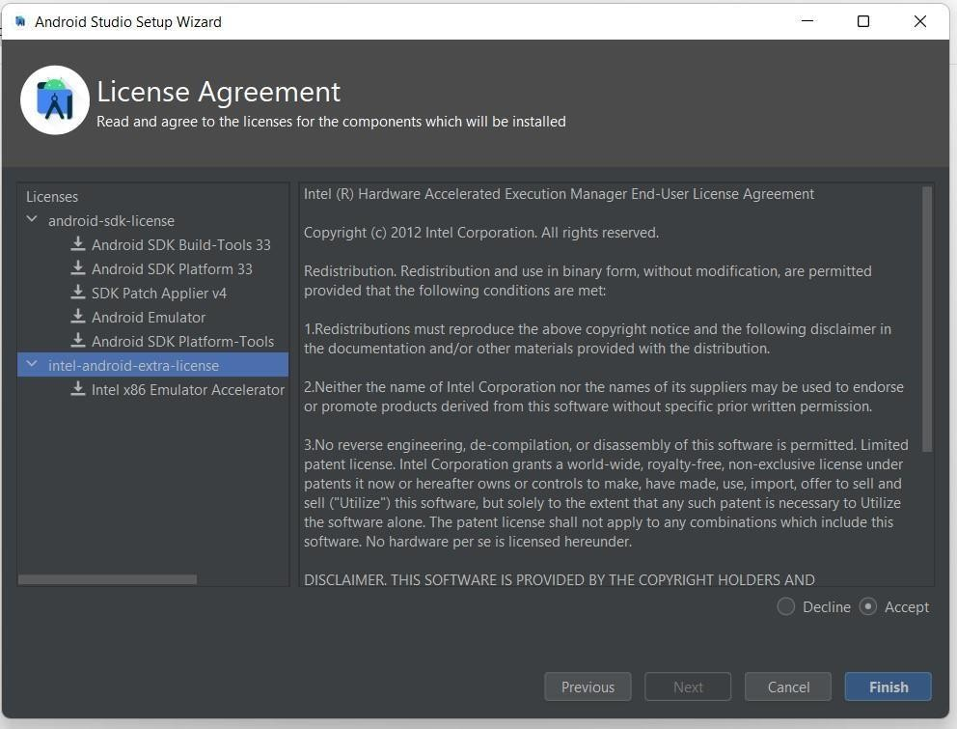

1. Let all the components get downloaded. After all the components are downloaded, click on finish.

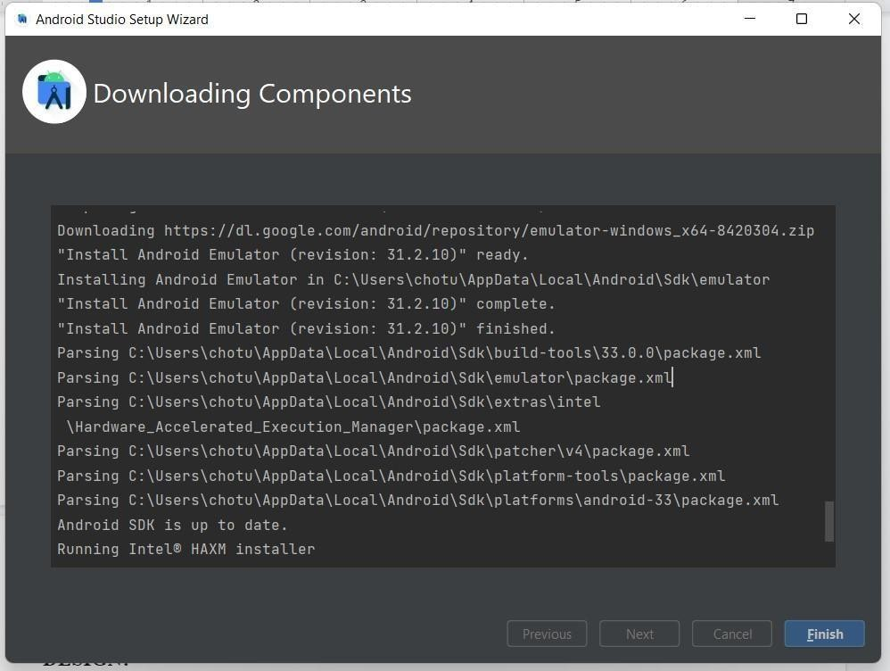

1. Download & installation of android studio & SDK has been completed. You can now create a new project by clicking on New Project.

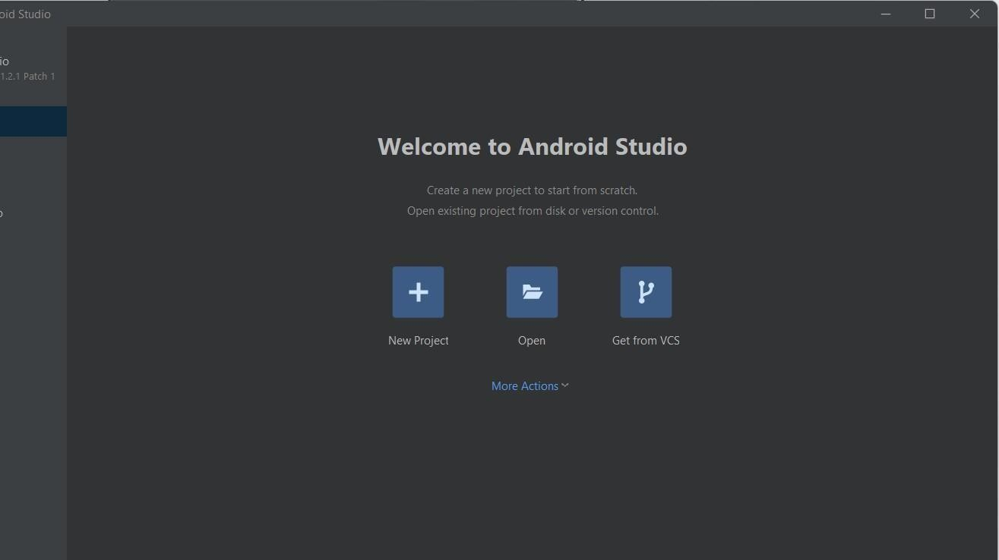

## CONCLUSION:

In this practical, we learnt about how to set up, download & install Android Studio in our laptops.

**1.2} AIM:** Introduction to Android and Create “Custom Message” application. That will display “Custom Message” in the middle of the screen in the Black color with the Yellow background.

**DESIGN: Same as Output. CODE:**

package com.example.prac12;

import android.os.Bundle; import android.widget.TextView;

import androidx.appcompat.app.AppCompatActivity; import androidx.constraintlayout.widget.ConstraintLayout;

public class MainActivity extends AppCompatActivity { TextView tv;

ConstraintLayout cl; *@Override* protected void onCreate(Bundle savedInstanceState) { super.onCreate(savedInstanceState); setContentView(R.layout.*activity_main*); tv = findViewById(R.id.*textView*); cl = findViewById(R.id.*cons*);

cl.setBackgroundColor(getResources().getColor(R.color.*purple_200*)); tv = setTextColor(getResources().getColor(R.color.*black*));

} }

## OUTPUT:

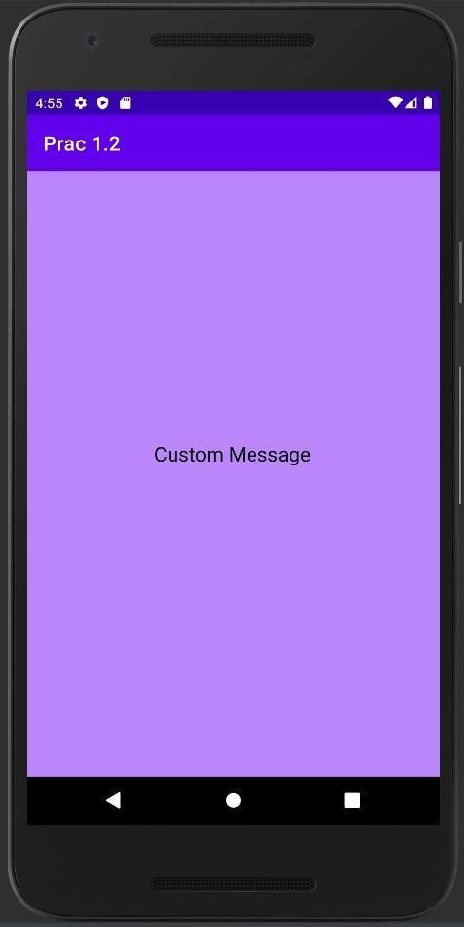

**CONCLUSION:**

In this practical, we learnt about how we can add a normal text (TextView) in the middle of our activity & how we can change the background of our activity.